


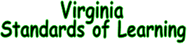
Dear Educator,

Our programs in teambuilding have been designed to assist student achievement. They meet the commonwealth of Virginia’s SOL academic expectations in the areas of English, Life Science, Physical Education and Health.

Maximize your student’s learning experience by incorporating these areas of achievement into your lesson plans as you prepare for your visit to The EDGE. Use these educational achievement areas as tools to:

- gain field trip approval
- solicit buy-in from colleagues
- answer parental questions
- request PTA funding
- support a grant request

The EDGE facilitation staff will strive to work with you to make your day with us a fun-filled experiential learning experience.
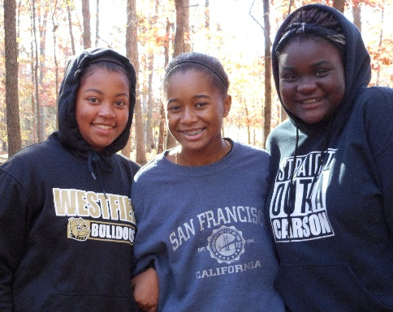
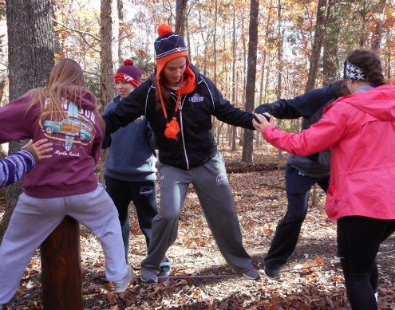
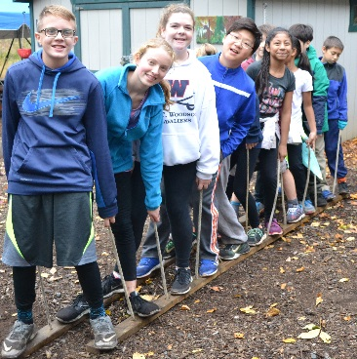
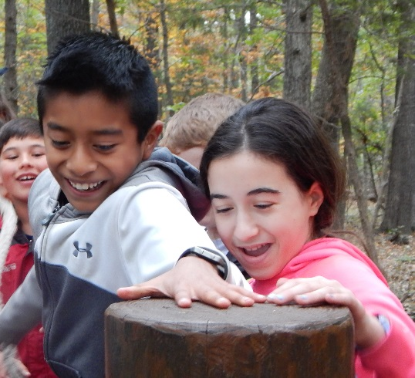
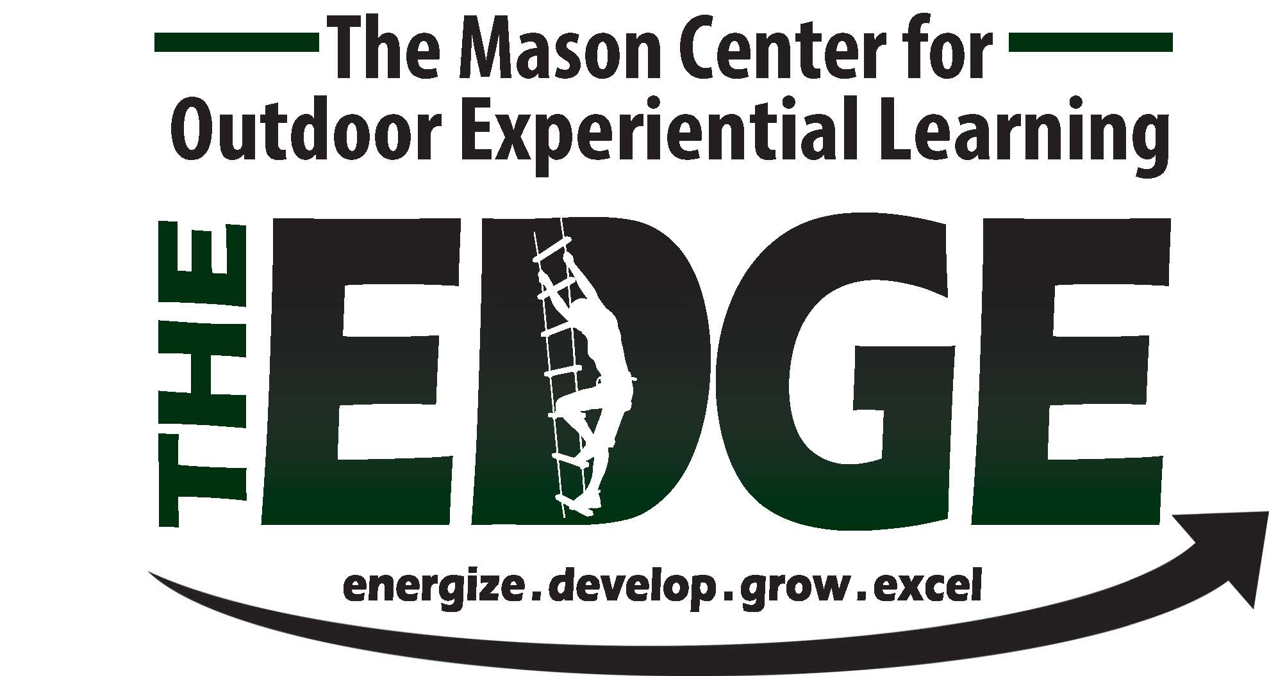
GRADE FIVE
VA SOL Applications for the Team Development Course

 | CONCEPT AREA | STANDARD  CODE | CONCEPT DESCRIPTION
In GRADE FIVE, students will demonstrate the ability to collaborate with diverse teams working respectfully with others, using active listening skills, and showing value for individual contributions.
ENGLISH | Communication and Multimodal Literacies | 5.1 | The student will use effective oral communication skills in a variety of settings.  - Listen actively and speak using appropriate discussion rules with awareness of verbal and nonverbal cues.  - Participate in and contribute to discussions across content areas.  - Orally express ideas clearly in pairs, diverse groups, and whole class settings.  - Demonstrate the ability to collaborate with diverse teams, while sharing responsibility for the work.  - Work respectfully with others and show value for individual contributions.
ENGLISH | Communication and Multimodal Literacies | 5.2 | The student will create multimodal presentations that effectively communicate ideas.  - Maintain eye contact with listeners.  - Ask and answer questions to gather or clarify information presented orally.
Students in GRADE FIVE apply movement principles and concepts and knowledge of anatomical structures and functions to enhance their movement performance, personal fitness, and game strategy and tactics. They develop proficiency in physical activities, dances, and educational gymnastics. Students demonstrate specialized skills alone, with a partner, or in a small group. They access and use resources to plan and improve personal fitness as they exhibit a physically active lifestyle. Students continue to develop responsible personal and social behaviors as they work with others in safe and respectful ways.
PHYSICAL EDUCATION | Anatomical Basis of Movement | 5.2 | The student will apply anatomical knowledge and movement strategies in complex movement activities  - Identify components of major body systems, to include cardiorespiratory, vascular, muscular, and skeletal.  - Apply knowledge of body systems, bones, and muscles to accurately describe a variety of specific movements such as a ball strike, overhand throw, or volley.  - Describe concepts of direction and force used to strike an object with purpose and accuracy.
PHYSICAL EDUCATION | Social Development | 5.4 | The student will participate in establishing and maintaining a safe environment for physical activities.  - Create and implement rules and consequences for one or more activities.  - Create and implement safety rules for at least one activity.  - Create and implement etiquette for one activity.  - Explain the importance of inclusion in physical activity settings.  - Describe and demonstrate respectful behavior in physical activity settings.
Students in GRADE FIVE distinguish reliable from unreliable health information and resources. Students’ practices and behaviors demonstrate health knowledge and skills. Emphasis is placed on demonstrating interpersonal skills, assuming responsibility for personal health habits, and practicing behaviors that promote active, healthy lifestyles. Students analyze the influences of advertising and various media on personal and community health.
HEALTH | Essential Health Concepts | 5.1 | The student will analyze the impact of positive health behaviors and risky behaviors on personal health.  - Analyze why people choose to follow or not follow safety rules at home, at school, and in the community.  - Recognize the development of positive social skills as essential for building and sustaining relationships.  - Identify effective verbal and nonverbal communication skills that convey care, consideration, and respect for self and others.  - Analyze the role of active listening in refusal and conflict resolution.
HEALTH | Healthy Decisions | 5.2 | The student will demonstrate responsibility for developing personal health habits and practicing behaviors that promote an active, healthy lifestyle.  - Recognize the importance of developing and maintaining a positive self-image.  - Demonstrate effective communication skills to address harassing behaviors.  - Demonstrate how to show respect for individual differences.
HEALTH | Advocacy and Health Promotion | 5.3 | The student will explain how peers, families, and community groups work together to promote health, prevent disease, and create a healthy community.  - Identify physical activities that students can do with friends and family to build positive relationships.  - Examine the role of self and others in causing or preventing injuries.  - Explain the benefits of having positive relationships with family, friends, and neighbors.  - Describe ways to offer friendship and support to someone who was bullied.  - Promote volunteerism and community service.  - Recognize that all individuals have a responsibility to protect and preserve the environment.  - Develop a plan to work collaboratively with peers, families, and community groups to address community environmental issues.

GRADE SIX
VA SOL Applications for the Team Development Course

 | CONCEPT AREA | STANDARD  CODE | CONCEPT DESCRIPTION
In GRADE SIX, students continue to build upon skills previously taught in earlier grades.
ENGLISH | Communication and Multimodal Literacies | 6.1 | The student will use effective oral communication skills in a variety of settings.  - Listen actively and speak using appropriate discussion rules with awareness of verbal and nonverbal cues.  - Participate as a facilitator and a contributor in a group.  - Participate in collaborative discussions with partners building on others’ ideas.  - Ask questions to clarify the speaker’s purpose and perspective.  - Summarize and evaluate group activities.  - Analyze the effectiveness of participant interactions.  - Evaluate own contributions to discussions.  - Demonstrate the ability to collaborate with diverse teams.  - Work respectfully with others and show value for individual contributions.
Students in GRADE SIX apply fundamental skills and knowledge of anatomical structures and movement principles to build movement competence and confidence through acquisition, performance, and refinement of skills. Cooperative and competitive small-group games are appropriate as well as outdoor pursuits, fitness activities, dance and rhythmic activities, aquatics, individual performance activities, and sports (net/wall, striking/fielding, and goal/target), with an emphasis on developing skills and tactical understanding. Students use feedback to initiate and maintain practice to improve skill performance. Students assess their health-related fitness status and set reasonable and appropriate goals for development, maintenance, and improvement. Students in grade six will explain the connection between energy balance and nutrition guidelines, meal planning, and heart rate.
Social interaction becomes more complex as peer pressure becomes increasingly pronounced, impacting individual performance. Students solve problems and make responsible decisions as they work together. They identify and seek opportunities to participate in regular physical activity at school and outside the school environment.
PHYSICAL EDUCATION | Motor Skill Development | 6.1 | The student will demonstrate and apply mature movement forms in a variety of activities and identify the six components of skill-related fitness.  - Combine and apply mature locomotor and manipulative skills into specialized sequences and small-group modified game-play that includes dynamic and unpredictable situations.  - Identify the six components of skill-related fitness (agility, balance, coordination, power, reaction time, and speed).  - Analyze movement situations for direction, speed, accuracy, and pathways to improve performance.
PHYSICAL EDUCATION | Anatomical Basis of Movement | 6.2 | The student will apply both movement principles and concepts and knowledge of anatomical structures to movement-skill performance.  - Refine and adapt individual and group activity skills by applying concepts of relationships, effort, spatial awareness, speed, and pathways.
 | Social Development | 6.4 | The student will demonstrate and apply skills of communication, conflict resolution, and cooperation to achieve individual and group goals that apply to working independently and with others in physical activity settings.  - List and demonstrate problem solving, conflict resolution, and decision-making skills.  - Reflect on completion of an improvement plan for a personally challenging skill or activity.  - Describe the benefits of competitive and non-competitive physical activities.  - Demonstrate integrity and apply rules/etiquette for a team-building activity.  - Create and implement strategies, to include others and promote safe participation in physical activities.
Students in GRADE SIX develop more sophistication in understanding health issues and practicing health skills. They apply physical, emotional, social, and environmental health skills and strategies to improve or maintain personal and family health. Students begin to understand adolescent health issues and concerns and the relationship between choices and consequences. They understand how to be a positive role model and the impact of positive and negative peer pressure. Students demonstrate injury-prevention behaviors at school and elsewhere.
HEALTH | Essential Health Concepts | 6.1 | The student will apply critical-thinking skills and personal-management strategies to address issues and concerns related to personal health and wellness.  - Identify and interpret nonverbal cues.  - Describe the possible effects of bullying, to include the increased risk for harm and violence when bullying aggression persists.  - Explain methods to reduce conflict, harassment, and violence.  - Identify personal characteristics that can contribute to happiness for self and others (e.g., self-discipline, positive self-image, independence, acceptance of others, concern for the needs of individuals with disabilities, honesty, respect for self and others, avoidance of self-harming behaviors).  - Analyze the factors that contribute to group success (e.g., respecting individual differences and opinions, accepting responsibility, contributing positively, knowing when to lead and when to follow, dealing with conflict, using effective face-to-face and online communication skills).
HEALTH | Healthy Decisions | 6.2 | The student will describe the influence of family, peers, and media on personal health decisions.  - Explain the importance of accepting responsibility for personal actions to avoid risk-taking behaviors and injury.  - Recognize the importance of family, peers, and the media in preventing bullying.  - Analyze the role of emotions in safe behaviors and violent behaviors, and the importance of effective conflict resolution skills.  - Explain the importance of understanding the feelings and perspectives of others.  - Identify internal factors, such as criticism or stress, which influence emotional and social health.
HEALTH | Advocacy and Health Promotion | 6.3 | The student will develop personal strategies and skills for personal, social, and community health.  - Develop a plan to remain injury free that includes avoiding risk-taking behaviors and using protective gear.  - Demonstrate ways to show respect for individual differences, opinions, and beliefs.  - Set personal boundaries for privacy, safety, and expression of emotions and opinions.  - Assess positive and negative responses to criticism.  - Evaluate a plan to prevent or manage the effects of bullying.  - Practice ways to resolve conflict nonviolently.  - Identify the relationships among personal actions, self-image, and personal success

GRADE SEVEN
VA SOL Applications for the Team Development Course

 | CONCEPT AREA | STANDARD  CODE | CONCEPT DESCRIPTION
In GRADE SEVEN, students continue to build upon skills previously taught in earlier grades. Students share responsibility for collaborative work, as both a contributor and a facilitator, while working for consensus to accomplish goals.
ENGLISH | Communication and Multimodal Literacies | 7.1 | The student will participate in and contribute to conversations, group discussions, and oral presentations.  - Use a variety of strategies to listen actively and speak using agreed upon discussion rules with awareness of verbal and nonverbal cues.  - Clearly communicate ideas and information orally in an organized and succinct manner.  - Ask probing questions to seek elaboration and clarification of ideas.  - Participate in collaborative discussions with partners building on others’ ideas.  - Make statements to communicate agreement or tactful disagreement with others’ ideas.  - Use language and style appropriate to audience, topic, and purpose.  - Work effectively and respectfully within diverse groups.  - Exhibit willingness to make necessary compromises to accomplish a goal.  - Share responsibility for collaborative work.
Students in GRADE SEVEN continue to develop competence in modified versions of various game/sport, rhythmic, and recreational activities. They vary movement during dynamic and unpredictable game situations. Recreational pursuits become an additional curriculum option, broadening lifelong physical activity options. The ability to analyze skill performance through observing and understanding critical elements (small, isolated parts of the whole skill or movement) is increasingly apparent, as is the application of basic scientific principles of anatomical structures, movement principles, energy balance, and personal fitness. Students relate the importance of physical activity to health, focusing particularly on obesity and stress. Students achieve and maintain personal fitness standards and create plans by setting reasonable and appropriate goals for improvement or maintenance of health-related fitness. Students continue to develop social skills and cooperative behaviors by demonstrating problem solving, conflict resolution, communication skills, appropriate etiquette, integrity, and respect for others.
PHYSICAL EDUCATION | Motor Skill Development | 7.1 | The student will demonstrate competence and apply movement concepts in modified versions of various game/sport, rhythmic, and recreational activities.  - Demonstrate and apply mature movement forms and skill combinations competently in a variety of cooperative and tactical activities that include dynamic and unpredictable situations.  - Demonstrate basic abilities and safety precautions in recreational pursuits (e.g., in-line skating, orienteering, hiking, cycling, ropes courses, backpacking, canoeing, and rock climbing).  - Describe and demonstrate how movement is stabilized, to include balance (center of gravity and center of support) and planes of movement.
 | Social Development | 7.4 | The student will demonstrate and apply skills to work independently and with others in physical activity settings.  - Explain the importance of cooperating with classmates, and demonstrate supportive behaviors that promote the inclusion and safety of others.  - Demonstrate effective communication skills by providing feedback to a peer, using appropriate tone and other communication skills.
Students in GRADE SEVEN generate and choose positive alternatives to risky behaviors. They use skills to resist peer pressure and manage stress and anxiety. Students are able to relate health choices to alertness, feelings, and performance at school or during physical activity. Students exhibit a healthy lifestyle, interpret health information, and promote good health.

HEALTH | Essential Health Concepts | 7.1 | The student will identify and explain essential health concepts to understand personal health.  - Analyze the benefits of stress management and stress-reduction techniques.  - Develop strategies for coping with disappointment.  - Identify physical, social, and emotional factors that affect school success.  - Identify the benefits of healthy interpersonal relationships.  - Differentiate between passive, aggressive, and assertive communication.  - Explain how violence, bullying, and harassment affect health and safety.  - Describe the role of empathy in preventing bullying (in school and online).
HEALTH | Healthy Decisions | 7.2 | The student will use decision-making skills to promote health and personal wellness.  - Describe how peers influence healthy and unhealthy behaviors.  - Explain the benefits of emotional flexibility, stress management, and stress-reduction techniques for emotional health.  - Explain why it is important to prevent bullying at school and online.
HEALTH | Advocacy and Health Promotion | 7.3 | The student will promote healthy schools, families, and communities.  - Promote strategies for coping with disappointment and adversity.  - Create a campaign to prevent bullying in school and online.
The Life Science standards continue to focus on student growth in understanding the nature of science. This scientific view defines the idea that explanations of nature are developed and tested using observation, experimentation, models, evidence, and systematic processes.
SCIENCE | Life Science | LS.8 | The student will investigate and understand interactions among populations in a biological community. Key concepts include:  - the relationships among producers, consumers, and decomposers in food webs;  - the relationship between predators and prey;  - competition and cooperation;  - symbiotic relationships; and  - niches

GRADE EIGHT
VA SOL Applications for the Team Development Course

 | CONCEPT AREA | STANDARD CODE | CONCEPT DESCRIPTION
In GRADE EIGHT, students continue to build upon skills previously learned in earlier grades.
ENGLISH | Communication and Multimodal Literacies | 8.1 | The student will participate in, collaborate in, and report on small-group learning activities.  - Exhibit willingness to make necessary compromises to accomplish a goal.  - Collaborate with others to exchange ideas, develop new understandings, make decisions, and solve problems.  - Include all group members, and value individual contributions made by each group member.  - Make statements to communicate agreement or tactful disagreement with others’ ideas.  - Use a variety of strategies to listen actively and speak using appropriate discussion rules with awareness of verbal and nonverbal cues.  - Use self-reflection to evaluate one’s own role in preparation and participation in small-group activities.
Students in GRADE EIGHT demonstrate competence in skillful movement in modified, dynamic game/sport situations and in a variety of rhythmic and recreational activities. They transition from modified versions of movement forms to more complex applications across all types of activities. The grade-eight student applies knowledge of major body structures to explain how body systems interact with and respond to physical activity and how structures help the body create movement. Students will explain the relationship between nutrition, activity, and body composition to deepen understanding of energy balance. They will demonstrate socially responsible behavior as they show respect for others, make reasoned and appropriate choices, resist negative peer pressure, and exhibit integrity and fair play to achieve individual and group goals in the physical activity setting. Students are able to set goals, track progress, and participate in physical activities to improve health-related fitness. They have a repertoire of abilities across a variety of game/sport, dance, and recreational pursuits and begin to develop competence in specialized versions of lifelong game/sport activities.
PHYSICAL EDUCATION | Motor Skill Development | 8.1 | The student will apply and demonstrate movement concepts and skills in modified versions of various game/sport, rhythmic, and recreational activities.  Use skill combinations competently in specialized versions of individual, dual, and team activities.  a. Demonstrate and apply movement forms to a variety of cooperative and tactical activities that include dynamic and unpredictable situations with a focus on defensive strategies, to include reducing space, transitioning from offense to defense quickly, communicating with teammates, and selecting appropriate tactics to gain defensive advantage.  e. Demonstrate balance (center of support and center of gravity) in a variety of activities.
PHYSICAL EDUCATION | Social Development | 8.4 | The student will describe and apply a variety of social and safety skills to achieve individual and group goals in a variety of physical activity settings.  - Describe and demonstrate best practices for participating safely in physical activity, exercise, and dance (e.g., injury prevention, proper alignment, hydration, use of equipment, implementation of rules, sun protection).  - Describe and demonstrate appropriate encouragement and feedback to peers without prompting from the teacher.  - Identify and demonstrate proper etiquette, respect for others, integrity, and teamwork while engaging in physical activity and/or social dance.  - Apply communication skills and strategies that promote team/group dynamics.  - Describe and demonstrate conflict-resolution skills.  - Apply problem solving skills in cooperative and dynamic physical activities and/or dance settings.
Students in GRADE EIGHT have an understanding of the origins and causes of diseases, including the relationship between family history and certain health risks. They begin to relate short- and long-term consequences of health choices and apply health skills to specific personal, family, and community health concerns. Students can discern relationships among all components of health and wellness and knowledgeably use consumer information.
HEALTH | Essential Health Concepts | 8.1 | The student will identify and explain essential health concepts to demonstrate an understanding of personal health.  - Analyze the role of tolerance and resilience in coping with stress.  - Explain how individual, social, and cultural differences may increase vulnerability to bullying.
HEALTH | Healthy Decisions | 8.2 | The student will apply health concepts and skills to the management of personal and family health.  - Evaluate the importance of developing relationships that are positive and promote wellness.  - Recognize warning signs associated with bullying behaviors (e.g., declining grades, fear of attending school, social withdrawal, lost or destroyed books or technology, self-destructive behaviors).
HEALTH | Advocacy and Health Promotion | 8.3 | The student will undertake health-promotion activities that demonstrate an understanding of the relationship between nutrition, physical activity, and emotional and physical health.  - Evaluate the physical, mental, and social benefits of physical activity.  - Identify strategies to increase water intake.  - Identify ways for students to develop relationships that are positive, promote wellness, and prevent gang involvement.  - Describe healthy ways to handle the emotional, psychological, and physical consequences of stress.  - Justify and encourage safe, respectful, and responsible relationships  - Create strategies for helping others prevent or get help with bullying.  - Analyze opportunities for community service.

GRADES NINE

VA SOL Applications for the Team Development Course

 |  | CONCEPT AREA | STANDARD  CODE | CONCEPT DESCRIPTION
In GRADE NINE, students will continue to work in collaborative groups assisting with setting rules and working toward consensus.
ENGLISH | Communication and Multimodal Literacies |  | 9.1 |  | The student will participate in, collaborate in, and make multimodal presentations both independently and in small groups.  - Credit information sources.  - Use vocabulary appropriate to the topic, audience, and purpose.  - Assist with setting rules for group work including informal consensus, taking votes on key issues, presentation of alternate views and goal setting.  - Share responsibility for collaborative work.  - Use a variety of strategies to listen actively and speak using appropriate discussion rules with awareness of verbal and nonverbal cues.  - Include all group members, acknowledge new information expressed by others, and value individual contributions made by each group member.  - Respond thoughtfully and tactfully to diverse perspectives, summarizing points of agreement and disagreement.  - Use self-reflection to evaluate one’s own role in preparation and participation in small-group activities.
Students in GRADE NINE complete the transition from modified versions of movement forms to more complex applications across all types of physical activities. This may include outdoor pursuits, fitness activities, dance and rhythmic activities, aquatics, individual performance activities, and games and sports (net/wall, striking/fielding, and goal/target). Students demonstrate the ability to use basic skills, strategies, and tactics in a variety of lifetime physical activities. Students demonstrate more specialized knowledge in identifying and applying key movement concepts and principles. Students will explain the importance of energy balance and nutritional needs of the body to maintain optimal health and prevent chronic disease. They self-assess their skill performance and develop a personal physical activity program aimed at improving motor skills, movement patterns, and strategies essential to performing a variety of physical activities. They apply their understanding of personal fitness to lifelong participation in physical activity. Students demonstrate independence in making choices, respecting others, avoiding conflict, resolving conflicts appropriately, and using elements of fair play and ethical behavior in physical activity settings. Students demonstrate the knowledge, skills, and abilities required to plan for and improve components of fitness and achieve and maintain a health-enhancing level of personal fitness.
PHYSICAL EDUCATION |  | Motor Skill Development | 9.1 | The student will perform all basic movement skills and demonstrate movement and biomechanical principles in a variety of activities that may include outdoor pursuits, fitness activities, dance and rhythmic activities, aquatics, individual performance activities, and games and sports (net/wall, striking/fielding, and goal/target(s)).  - Apply the concepts and principles of levers, force, motion, and rotation in a variety of activities.
 |  | Social Development | 9.4 | The student will explain and demonstrate the skills needed to be safe, responsible, and respectful in all physical activity settings.  - Identify and demonstrate proper etiquette, respect for others, integrity, and teamwork while engaging in a variety of activities.  - Explain the impact of sports and activities in developing respect for the unique characteristics, differences and abilities of peers.  - Apply conflict-resolution skills in physical activity settings.  - Apply communication skills and strategies that promote positive team/group dynamics.  - Apply problem-solving and critical-thinking skills in physical activity settings, both as an individual and in groups.  - Apply best practices for participating safely in physical activity, exercise, and dance (e.g., injury prevention, proper alignment, hydration, use of equipment, implementation of rules, sun protection).  - Analyze and compare psychological benefits derived from various physical activities (e.g., decreased stress and anxiety, increased self-esteem, increased mental alertness, improved mood).
Students in GRADE NINE integrate a variety of health concepts, skills, and behaviors to plan for their personal, lifelong health goals. These include awareness and consequences of risky behaviors, disease prevention, overall wellness, and identification of community health resources. Students demonstrate competence in their knowledge and skills. They see themselves as having an active role in creating a healthy lifestyle for themselves, for their families, and for the community.
HEALTH |  | Healthy Decisions | 9.2 | The student will explain the impact of health risks and identify strategies and resources to limit risk.  - Demonstrate peaceful resolution of conflicts.
 |  | Advocacy and Health Promotion | 9.3 | The student will demonstrate skills to advocate for personal and community health.  - Determine how to help a friend exhibiting signs of depression, anxiety, disordered eating, or other self-harming behavior.  - Utilize appropriate resolution skills to prevent, prepare for, and manage conflict in a variety of situations.

GRADE TEN

VA SOL Applications for the Team Development Course

 | CONCEPT AREA | STANDARD  CODE | CONCEPT DESCRIPTION
In GRADE TEN, students continue to build upon skills learned in earlier grades
ENGLISH | Communication and Multimodal Literacies | 10.1 | - Demonstrate the ability to work effectively with diverse teams including setting rules and goals for group work such as coming to informal consensus, taking votes on key issues, and presenting alternate views.  - Include all group members and value individual contributions made by each group member.  - Use a variety of strategies to listen actively and speak using appropriate discussion rules with awareness of verbal and nonverbal cues.  - Respond thoughtfully and tactfully to diverse perspectives, summarizing points of agreement and disagreement.  - Choose vocabulary, language, and tone appropriate to the topic, audience, and purpose.  - Access, critically evaluate, and use information accurately to solve problems.  - Use reflection to evaluate one’s own role and the group process in small-group activities.
Students in GRADE TEN are proficient in fundamental movement skills and skill combinations and are competent in self-selected physical activities that they are likely to pursue throughout life including outdoor pursuits, fitness activities, dance and rhythmic activities, aquatics, selected individual performance activities, and net/wall and target games. They understand and apply concepts and principles of mechanics and anatomy in relation to human movement and apply the concepts and principles of the body’s metabolic response to short-term and long-term physical activity. Students are good leaders and good followers; they respect others, and anticipate and avoid unsafe physical activity situations. They develop the ability to understand and they anticipate how physical activity interests and abilities change across a lifetime. Students demonstrate competency in lifelong physical activities and plan, implement, self-assess, and modify a personal fitness plan. Students are prepared to lead a physically active lifestyle.
PHYSICAL EDUCATION | Fitness Planning | 10.3 | The student will demonstrate the ability to apply basic principles of training and scientific concepts and principles to evaluate current fitness behaviors and identify strategies needed for health-enhancing fitness for the present and into adulthood.  - Identify the impact of life choices, economics, motivation, accessibility, exercise adherence, and participation in physical activity in college or career settings.
PHYSICAL EDUCATION | Social Development | 10.4 | The student will demonstrate appropriate behaviors in all physical activity settings and the social skills needed to be a contributing member of society.  - Explain the importance of and demonstrate communication skills in physical activity settings.  - Explain the importance of critical thinking and problem solving for current and future health and fitness.  - Identify and avoid potentially dangerous situations in physical activity settings.  - Evaluate opportunities for social interaction and social support in a self-selected physical activity or dance.  - Explain the importance of conflict resolution for current and future health and fitness.
Students in GRADE TEN demonstrate comprehensive health and wellness knowledge and skills. Their behaviors reflect a conceptual understanding of the issues associated with maintaining good personal health. They serve the community through the practice of health-enhancing behaviors that promote wellness throughout life.
HEALTH | Essential Health Concepts | 10.1 | The student will demonstrate an understanding of health concepts, behaviors, and skills that reduce health risks and enhance the health and wellness of self and others throughout life.  - Describe the health benefits of positive self-esteem, balance, flexibility, resilience, and healthy relationships with others.
HEALTH | Healthy Decisions | 10.2 | The student will analyze, synthesize, and evaluate the protective factors needed to make healthy decisions throughout life.  - Analyze the influence of emotions and peer approval on personal decision making.  - Explain the value of positive self-image, self-esteem, and self-control when faced with peer pressure.  - Evaluate the value of exercising self-control.  - Recognize the protective factors of assertiveness.  - Calculate the importance of support and encouragement from positive role models. Identify strategies for the peaceful resolution of conflicts.  - Compare and contrast assertive and aggressive communication and their effectiveness in conflict resolution.
HEALTH | Advocacy and Health Promotion | 10.3 | The student will advocate for personal health and well-being and promote health-enhancing behaviors for others.  - Demonstrate assertive communication skills  - Demonstrate effective negotiation skills  - Identify health promotion opportunities, and share talents and expand personal knowledge through community service-learning experiences.  - Practice procedures for peaceful resolution of conflicts.  - Model effective communication skills for addressing peer pressure.  - Present strategies to address abusive peer, family, and dating relationships.

GRADES ELEVEN AND TWELVE

VA SOL Applications for the Team Development Course

 | CONCEPT AREA | STANDARD  CODE | CONCEPT DESCRIPTION
The GRADE ELEVEN student continues to build communication skills working both independently and in collaborative groups. Students will continue to demonstrate the ability to work within collaborative groups while presenting alternate views and working toward common goals.
ENGLISH | Communication and Multimodal Literacies | 11.1 | - Demonstrate the ability to work collaboratively with diverse teams.  - Respond thoughtfully and tactfully to diverse perspectives, summarizing points of agreement and disagreement.  - Use a variety of strategies to listen actively and speak using appropriate discussion rules with awareness of verbal and nonverbal cues.  - Anticipate and address alternative or opposing perspectives and counterclaims.  - Use vocabulary appropriate to the topic, audience, and purpose.
The GRADE TWELVE student will continue to demonstrate the ability to work within diverse teams and collaborative groups working toward common goals.
ENGLISH | Communication and Multimodal Literacies | 12.1 | - Demonstrate the ability to work collaboratively with diverse teams.  - Anticipate and address alternative or opposing perspectives and counterclaims.  Use a variety of strategies to listen actively and speak using appropriate discussion rules with awareness of verbal and nonverbal cues.
Elective physical education courses provide students with the opportunity to participate in physical activities for specific purposes. Students in elective physical education demonstrate the knowledge and understanding necessary to analyze movement performance in an activity of choice using scientific principles, and implement effective practice procedures for skillful performance in specialized movement forms. Students apply advanced movement-specific information so that they develop the ability to learn, self-assess, and improve movement skills independently. Options for offering specialized-movement courses can be configured by quarter, by semester, or on a full-year basis. Students should be offered the opportunity to self-select an activity throughout the course. Students will select areas of concentration to study.
PHYSICAL EDUCATION | Social Development | 11/12.4 | The student will evaluate and implement a safe environment for skill practice and play and demonstrate social competency skills for lifetime activity participation.  - Demonstrate proper care of athletic/activity equipment.  - Demonstrate safe behavior when participating in or watching physical activity/sport.  - Explain and demonstrate leadership skills of problem solving, communication, and conflict resolution.  - Demonstrate the ability to work cooperatively to accomplish a group goal.  - Demonstrate respect for differences among people in physical activity settings.  - Develop and demonstrate strategies for inclusion of persons of diverse backgrounds and abilities.  - Identify ways that physical activities can provide positive social interaction, such as the benefits of team involvement and an individual’s role as a positive member of a group.

